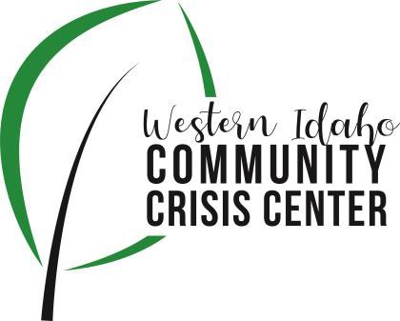
AGENDA

WIDCCC Advisory Group Location:
Gunderson Room, Southwest District Health

Conference/Video Information: Optional

Join Zoom Meeting https://swdh.zoom.us/j/925399635 95

Dial by your location

+1 669 900 6833 US (San Jose)
+1 646 876 9923 US (New York)
Meeting ID: 925 3996 3595
Password: 030953
Find your local number: https://swdh.zoom.us/u/abKHCu7MB7

Date: March 13, 2021

Time: 1:00pm – 2:00pm

Attendees:

 | Agenda Item | Presenter | Discussion | Next Steps
1:00 | Call to Order | Heather, Vice Chair | Introduction and call for any additional agenda items
1:05 | Advisory Committee Membership | Sam, SWDH | Where we are with membership (vacancies) and how new members are appointed. Who to target and how to get them here | Update Bylaws with Nomination Process
1:15 | Budget 2021-22 | Sam & Nikki, SWDH | Current budget planning, JFAC update
1:25 | Client Surveys | Heather, Vice Chair | Overview of current client survey. Is it asking what we need to know?
1:35 | Crisis Center Update | Sarah, Lifeways | Claims History and Sustainability  Census/Frequent Fliers  Optum Audit  Needs for the Crisis Center
1:55 | Wrap up and review next steps | Heather, Vice Chair | Assignments

