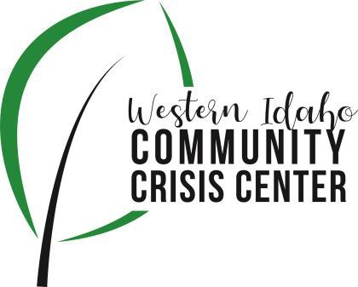
AGENDA

WIDCCC Advisory Committee Location:
Gunderson Room, Southwest District Health
Conference/Video Information: Optional
Join Zoom Meeting https://swdh.zoom.us/j/925399635 95
Dial by your location
+1 669 900 6833 US (San Jose)
+1 646 876 9923 US (New York)
Meeting ID: 925 3996 3595
Password: 030953
Find your local number: https://swdh.zoom.us/u/abKHCu7MB7

Date: July 14, 2021

Time: 1:00pm – 2:00pm

Attendees:
 | Agenda Item | Presenter | Discussion | Next Steps/Action
1:00 | Call to Order | Heather, Vice Chair | Introduction and call for any additional agenda items.
1:05 | Meeting Minutes | Heather, Vice Chair | Call for any revisions to the 6/9/21 meeting minutes. | Motion to Approve Minutes
1:10 | Officer Elections | Heather, Vice Chair | Elect Chair and Vice Chair for 1 year term | Vote in officers
1:15 | Funding Project Workgroup | Nikki Zogg, SWDH | Update on first meeting and next steps for planning and funding a project to address community needs associated with the crisis center
1:20 | Reg. 3 Shelters | Bill Roscoe, Guest | Discuss current situation with men’s shelters in region 3 and impacts on WIDCCC
1:40 | Crisis Center Update | Sarah and Caroline, Lifeways | Lifeways Crisis Center Update
1:55 | Wrap up | Heather, Vice Chair | Next Steps and Assignments | Next Meeting:  August 11, 2021

