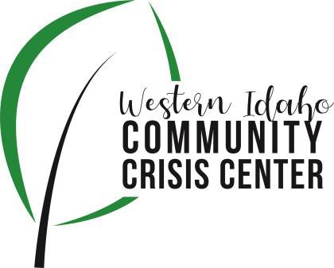
AGENDA

WIDCCC Advisory Committee Location:
Gunderson Room, Southwest District Health
Conference/Video Information: Optional
Join Zoom Meeting https://swdh.zoom.us/j/925399635 95
Dial by your location
+1 669 900 6833 US (San Jose)
+1 646 876 9923 US (New York)
Meeting ID: 925 3996 3595
Password: 030953
Find your local number: https://swdh.zoom.us/u/abKHCu7MB7

Date: August 11, 2021

Time: 1:00pm – 2:00pm

Attendees:
 | Agenda Item | Presenter | Discussion | Next Steps/Action
1:00 | Call to Order | Kelly, Chair | Introduction and call for any additional agenda items.
1:05 | Meeting Minutes | Kelly, Chair | Call for any revisions to the 7/14/21 meeting minutes. | Motion to Approve Minutes
1:10 | Webpage Update | Sam Kenney, SWDH | Update on working with Lifeways to update webpage and gain access to social media
1:15 | Funding Project Workgroup | Vito Kelso, Vice Chair | Update on planning and funding a project to address community needs associated with the crisis center
1:20 | Crisis Center Update | Sarah and Caroline, Lifeways | Lifeways Crisis Center Update
1:40 | Open discussion | Committee
1:55 | Wrap up | Kelly, Chair | Next Steps and Assignments | Next Meeting:  Sept. 8, 2021

