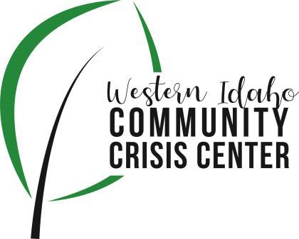
AGENDA

WIDCCC Advisory Committee Location:
WIDCCC, 524 Cleveland Blvd. In Caldwell
Conference/Video Information: Optional
Join Zoom Meeting https://swdh.zoom.us/j/925399635 95
Dial by your location
+1 669 900 6833 US (San Jose)
+1 646 876 9923 US (New York)
Meeting ID: 925 3996 3595
Password: 030953
Find your local number: https://swdh.zoom.us/u/abKHCu7MB7

Date: September 8, 2021

Time: 1:00pm – 2:00pm

Attendees:
 | Agenda Item | Presenter | Discussion | Next Steps/Action
1:00 | Call to Order | Kelly, Chair | Introduction and call for any additional agenda items.
1:05 | Meeting Minutes | Kelly, Chair | Call for any revisions to the 8/11/21 meeting minutes. | Motion to Approve Minutes
1:10 | Webpage Update | Sam Kenney, SWDH | Update and report out from meeting and progress
1:20 | Workgroup | Sam Kenney, SWDH | Update and report out from meeting and progress
1:30 | Crisis Center Update and Tour | Sarah and Caroline, Lifeways | Lifeways Crisis Center Update and Tour
1:50 | Wrap up | Kelly, Chair | Next Steps and Assignments | Next Meeting:  Oct. 13, 2021

