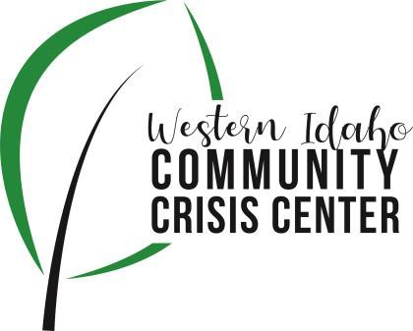
AGENDA

WIDCCC Advisory Group Location:
Gunderson Room, Southwest District Health

Conference/Video Information: Optional

Join Zoom Meeting https://swdh.zoom.us/j/925399635 95

Dial by your location

+1 669 900 6833 US (San Jose)
+1 646 876 9923 US (New York)
Meeting ID: 925 3996 3595
Password: 030953
Find your local number: https://swdh.zoom.us/u/abKHCu7MB7

Date: March 13, 2021

Time: 1:00pm – 2:00pm

Attendees:

Heather Taylor, Kelly Aberasturi, Sam Kenney,

Nikki Zogg, Sheri Ainsworth, Joan Agee, Arron Schrieber,

Joy Hussmann, Sarah Andrade, Caroline Bell

 | Agenda Item | Presenter | Discussion | Next Steps
1:00 | Call to Order | Heather, Vice Chair | Introduction and call for any additional agenda items – none requested
1:05 | Advisory Committee Membership | Sam, SWDH | Where we are with membership (vacancies) and how new members are appointed. Who to target and how to get them here?  Sam described past process in SWDH BOH appointments. Explained and reviewed how bylaws don’t currently describe this process. Bylaws specify two year terms for membership and statute requires a local behavioral health consumer, physician, law enforcement, a county commissioner, and a minimum of 5 members. Bylaws were originally adopted in October of 2019. Discussion on vacancies, potential nominees, and maximum number of members preferred by the current members was had. It was recommended to update bylaws to better reflect process of nomination within the committee, followed by recommendation to appoint membership by the SWDH BOH. | Update Bylaws with Nomination Process – Sam will draft update and present at next committee meeting
1:15 | Budget 2021-22 | Sam & Nikki, SWDH | Current budget planning, JFAC update  Nikki gave an update on crisis center budget legislation and preparation to secure funding from the counties in relation to current legislation. | Sam will provide Quarter 3 update on budget next meeting.  County funding updates included.
1:25 | Client Surveys | Heather, Vice Chair | Overview of current client survey. Is it asking what we need to know?  Lifeways has done some research in how to get more clients to participate and provide better data to the committee and presented findings. Lifeways plans to begin implementing an electronic version of the survey that will also be able to pull data for reporting purposes starting within the next couple weeks.
1:35 | Crisis Center Update | Sarah, Lifeways  Power point presentation can be found here. | Claims History and Sustainability –  Sarah presented insurance billing data from 2021.  Census/Frequent Fliers –  Sarah presented average census data and discussed the increase in return clients during the COVID pandemic with closings of local homeless shelters, especially those for adult males, and the persistent need to keep clients from staying overnight in the elements. Lifeways, with Caroline Bell leading, has begun meeting bi-weekly with multiple organizations including behavioral health, PATH, and the crisis center to discuss clients that are homeless and how to connect them to resources.  Optum Audit –  Sarah presented on Optum audit and the resulting corrective action plan the crisis center has begun implementing to address issues found in the audit. This included concern of accepting too many homeless clients and return clients during COVID and the fore mentioned bi-weekly meeting is part of the CAP.  Needs for the Crisis Center –  The Crisis Center continues to operate with minimum staff and needs help recruiting staff. | Sam and Sarah can work together to develop a template for monthly data to report to committee – expect it in iterations. Include law enforcement referrals  Client Survey data  Billing/reimbursement over time.
1:55 | Wrap up and review next steps | Heather, Vice Chair | Assignments:  See next steps  Caroline – connect with Aaron and BH outreach to better coordinate and train officers in Nampa

