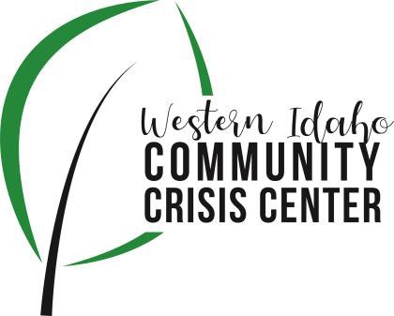
AGENDA

WIDCCC Advisory Committee Location:
Gunderson Room, Southwest District Health
Conference/Video Information: Optional
Join Zoom Meeting https://swdh.zoom.us/j/925399635 95
Dial by your location
+1 669 900 6833 US (San Jose)
+1 646 876 9923 US (New York)
Meeting ID: 925 3996 3595
Password: 030953
Find your local number: https://swdh.zoom.us/u/abKHCu7MB7

Date: July 14, 2021

Time: 1:00pm – 2:00pm
Attendees: Rebecka Koepnick, Caroline Bell, Sarah Andrade, Heather Taylor, Commissioner Kelly Aberasturi, Rev. Bill Roscoe (Guest), Vito Kelso, Sherrie Benners, Nikki Zogg

 | Agenda Item | Presenter | Discussion | Next Steps/Action
1:00 | Call to Order | Heather, Vice Chair | Introduction and call for any additional agenda items.
1:05 | Meeting Minutes | Heather, Vice Chair | Call for any revisions to the 6/9/21 meeting minutes. | Motion made by Vito, seconded by Kelly and passed unanimously.
1:10 | Officer Elections | Heather, Vice Chair | Elect Chair and Vice Chair for 1 year term | Vote in officers  Heather made a motion, to approve the nominations, Rebekah seconded, passed unanimously.  Chair: Kelly Aberasturi  Vice Chair: Vito Kelso
1:15 | Funding Project Workgroup | Nikki Zogg, SWDH | Update on first meeting and next steps for planning and funding a project to address community needs associated with the crisis center
1:20 | Reg. 3 Shelters | Bill Roscoe, Guest | Discuss current situation with men’s shelters in region 3 and impacts on WIDCCC  Bill Roscoe presented on the Boise Rescue Mission programs in Canyon County. one men’s shelter in Nampa, Canyon County, one for women and children (Valley Women and Children), and a recovery lodge (men, women, and children)  Shelters have become non-existent. The Nampa Light House shelter has shifted focus to youth summer program. BRM has 15 staff vacancies and had a decline in demand at the Light House shelter. Consistently see 2-3 men per day. Ontario is seeing a growing problem with homelessness, and surmise that it may have something to do the additional services and support in Oregon (e.g., camping for free on public lands, no drug regulations, etc.). Not seeing large camps. Rev. Roscoe discussed the number of resources they have available to them such as clothing, food, and hygiene packs. Pre-pandemic Canyon County shelter census is approximately 20-30 in the summer and 100+ in the winter. Approximately, 25% chronically homelessness. BRM also provides some mental health services, including medication management.
1:40 | Crisis Center Update | Caroline, Lifeways | Lifeway's update: Seen a drastic decline in daily visits. Outreach staff have been making rounds. Facility is now fully staffed. Corrective action plan accepted by Optum. Region 3 staff have been phenomenal with responding the same day to needs of clients. Caroline will be meeting with Pathways and Malheur Crisis Team supervisor and manager. Caroline is wanting to revamp and update the website and again access to the FB page.  Discussion regarding the drop in visits at WIDCCC, but hospital ED’s are being slammed. Boise has a crisis response team that goes out on LE calls when BH related. Region 3 staff coordinate with LE as requested, but only available Mon-Fri, 8am-5pm.
1:55 | Wrap up | Heather, Vice Chair | Next Steps and Assignments | Next Meeting:  August 11, 2021

