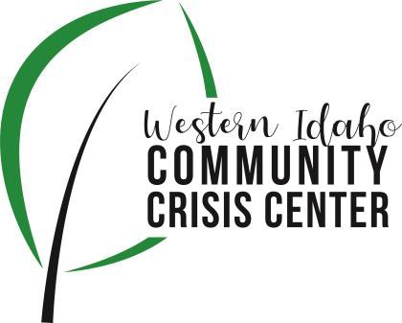
AGENDA

WIDCCC Advisory Committee Location:
WIDCCC, 524 Cleveland Blvd. In Caldwell
Conference/Video Information: Optional
Join Zoom Meeting https://swdh.zoom.us/j/925399635 95
Dial by your location
+1 669 900 6833 US (San Jose)
+1 646 876 9923 US (New York)
Meeting ID: 925 3996 3595
Password: 030953
Find your local number: https://swdh.zoom.us/u/abKHCu7MB7

Date: September 8, 2021

Time: 1:00pm – 2:00pm

Attendees:

In Person: Kelly Aberasturi, Heather Taylor, Sarah Andrade, Sam Kenney, and Caroline Bell

Virtually: Aaron Schrieber and Sheri Ainsworth
 | Agenda Item | Presenter | Discussion | Next Steps/Action
1:00 | Call to Order | Kelly, Chair | Introduction and call for any additional agenda items.  Kelly called the meeting to order and asked for any additions to the agenda. There were none.
1:05 | Meeting Minutes | Kelly, Chair | Call for any revisions to the 8/11/21 meeting minutes.  Motion made and carried to accept meeting minutes from August. | Motion to Approve Minutes
1:10 | Webpage Update | Sam Kenney, SWDH | Update and report out from meeting and progress  Sam described the three areas of focus for the WIDCCC web presence: the widccc.org website, the SWDH website, and social media. The widccc.org site really being focued on potential consumers/clients of the crisis center; the SWDH site focused on governance; and the social media as a tool to amplify reach and promotion of the crisis center. The team met and began the process of updating the widccc.org site to include the ideas of the committee. Sarah also took training on how to market and represent a crisis center in a trauma informed way. Ashley, the PIO for SWDH now has access to the site and has already fixed some formatting issues. The committee meets again on Monday and will meet every two weeks until changes are complete.
1:20 | Workgroup | Sam Kenney, SWDH | Update and report out from meeting and progress  The workgroup met and is focused on the need for a shelter with SUD and BH supports, especially for single men and individuals on probation. The workgroup continues to explore models that are having success in the area and is interested in understanding the current initiatives happening with others in the housing space. This workgroup has meetings with leadership from the housing coalition next Monday and is working on setting up meetings with two successful models already in existence in the area. These meetings will help answer the questions: Is there opportunity to expand and/or pay for more beds and services for crisis center clients, is there plans and a will to address the need for a men’s shelter in Canyon County, and how can we support or lead any efforts to get one up and running ASAP?  The committee discussed what the current efforts are and the impact that housing insecurity and homelessness have on individuals at the crisis center. It is evident that it impacts an individual’s ability to follow through on their plans and stay sober.
1:30 | Crisis Center Update and Tour | Sarah and Caroline, Lifeways | Lifeways Crisis Center Update and Tour  Caroline presented crisis center stats, projects, plans, and stuck points. The census dropped again in August and is continuing to be low this month so far. Caroline is meeting with several agencies, including Canyon County Probation, to explain the purpose and function of the crisis center. She is also working closely with Duck Valley Indian Reservation who has recently experienced a rash of deaths by suicide. Duck Valley officials have scheduled a tour of the crisis center and are exploring how they might partner, transport, and/or remotely offer crisis services and connect individuals to the option of mental holds. Caroline continues to regularly meet with the Salvation Army and Region 3 Behavioral Health on housing needs and with Optum for review of Medicaid clients accessing the center. Caroline continues to seek out opportunities for outreach to law enforcement agencies to educate on the crisis center. Transportation continues to be an issue with connections across state lines and with the requirements of the IROC grant. The Crisis Center continues to evaluate and plan for COVID related contingencies – quarantining staff and backfill as infections and exposures occur, social distancing and masking in the facility with staff and clients.  We then toured the facility. Observations of note:  The entry way has improved with covering on the glass to prevent seeing from the intake area into the center.  Carpet is hard to clean in the entry, and it would be nice to change out to tile or something easy to sanitize. Many individuals access the center not in their best state and have thrown up on the floor.
1:50 | Wrap up | Kelly, Chair | Next Steps and Assignments  Next meeting Oct. 13th, 2021  Continued project work on web presence and housing to be done between meetings and reported on at next meeting.  Meeting adjourned at 2:09 p.m. | Next Meeting:  Oct. 13, 2021

