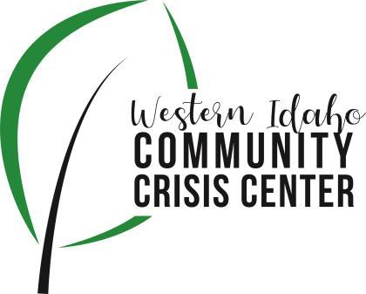
AGENDA

WIDCCC Advisory Committee Location:
WIDCCC, 524 Cleveland Blvd. In Caldwell
Conference/Video Information: Optional
Join the Microsoft Teams Meeting at the following link:
https://teams.microsoft.com/l/meetup-join/19%3ameeting_YTJjZTQ0NzgtZmU1Yy00ZTVkLWFhNWEtYzMxYTE2MDU2Nzhl%40thread.v2/0?context=%7b%22Tid%22%3a%22c8679a4d-fcef-44c7-8339-b6399dc28f6a%22%2c%22Oid%22%3a%222bc8351e-6079-4364-b560-14b9149b3522%22%7d

Date: March 9, 2022

Time: 1:00pm – 2:00pm

Attendees: Kelly Aberasturi, Hannah Hammudeh, Emily Baird, Adam Moravek, Rebekah Koepnick, Jennifer Burlage, Caroline Bell, Nikki Zogg, Sam Kenney, Sheri Aimsworth, TJ Orthmeyer, Nicole Coleman
 | Agenda Item | Presenter | Discussion | Next Steps/Action
1:00 | Call to Order | Kelly, Chair | Introduction and call for any additional agenda items.  Kelly called the meeting to order.
1:02 | Meeting Minutes | Kelly, Chair | Call for any revisions to the 1/12/22 meeting minutes. | Motion moved and seconded, Minutes Approved
1:05 | SWDH Update | Sam | Website/social media – press release – Findhelp.org – paramedics, etc.  Sam described website updates, getting social media to Adam, and SWDH PIO to produce press release to remind public of crisis centers services. Also, connecting to findhelp.org with crisis center.
1:15 | Crisis Center Update | Adam, Lifeways | Lifeways Crisis Center Update  Adam presented crisis center update. Discussed housing supports the crisis center is utilizing as well as the transportation services. Adam reported that he presented at the St. Luke’s staff meeting to inform on crisis center and other outreach efforts. Lastly, WIDCCC connected with SWDH and the Idaho Harm Reduction project to acquire Narcan for the crisis center to help prevent potential fentanyl overdose.  Nicole Coleman presented on 9-8-8. 9-8-8 will launch in July this year. We can look forward to more marketing and conversations in the coming months. Project is supported nationally by the Substance Abuse and Mental Health Service Administration (SAMSHA). The 3 elements needed in roll-out of 9-8-8 are someone to call, someone to respond, and some place to go. In Idaho, we have that in place now with our hotline, mobile response, and crisis centers. The state is working on integrating and creating a crisis care continuum. Nikki asked about whether it would be helpful for the health districts to promote a legislative resolution to stand up a telecommunications fee associated with 9-8-8 so the fees could further fund community crisis response efforts. Nicole said Idaho currently has no legislation around this but would like to start the conversation around sustainability with 9-8-8, but it may need to wait until a non-election year. Sam asked what will stay the same and what will change as 9-8-8 is implemented. Nicole responded that a lot would change but it would be slow and step by step. Nikki asked how calls will be handled by those under 18. Nicole said they will be handled the same, and texting will be added. Jen added that Region 3 Behavioral Health is trying to build out a more robust crisis system to the area. Jen is combining region 3 and 4 to better collaborate across the Treasure Valley. It is expected that crisis response will be available m-f, 8-5 in our region – currently building it out. 9-8-8 will centralize calls and free up staff to do more mobile response.
1:55 | Wrap up | Kelly, Chair | Next steps and any assignments  Sam: Set –up meeting with Jen and Lifeways on potential crisis center partnerships to mirror past efforts in reg. 4 | Next Meeting:  April 13, 2022  1:00 pm

