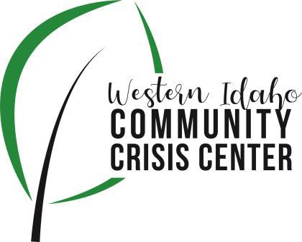
AGENDA

WIDCCC Advisory Committee Location:
WIDCCC, 524 Cleveland Blvd. In Caldwell
Conference/Video Information: Optional
Join the Microsoft Teams Meeting at the following link:
https://teams.microsoft.com/l/meetup-join/19%3ameeting_YTJjZTQ0NzgtZmU1Yy00ZTVkLWFhNWEtYzMxYTE2MDU2Nzhl%40thread.v2/0?context=%7b%22Tid%22%3a%22c8679a4d-fcef-44c7-8339-b6399dc28f6a%22%2c%22Oid%22%3a%222bc8351e-6079-4364-b560-14b9149b3522%22%7d

Date: April 13, 2022

Time: 1:00pm – 2:00pm

Attendees:
 | Agenda Item | Presenter | Discussion | Next Steps/Action
1:00 | Call to Order | Kelly, Chair | Introduction and call for any additional agenda items.
1:02 | Meeting Minutes | Kelly, Chair | Call for any revisions to the 3/9/22 meeting minutes. | Motion to Approve Minutes
1:05 | SWDH Update | Sam/NikkI | Youth Crisis Center and Reception Center Efforts, Region 3 SIM Conference
1:20 | Crisis Center Update | Adam, Lifeways | Lifeways Crisis Center Update
1:55 | Wrap up | Kelly, Chair | Next steps and any assignments | Next Meeting:  May 11, 2022  1:00 pm

